# Design Patterns

## Abstract Factory

### Illustrating code snippet

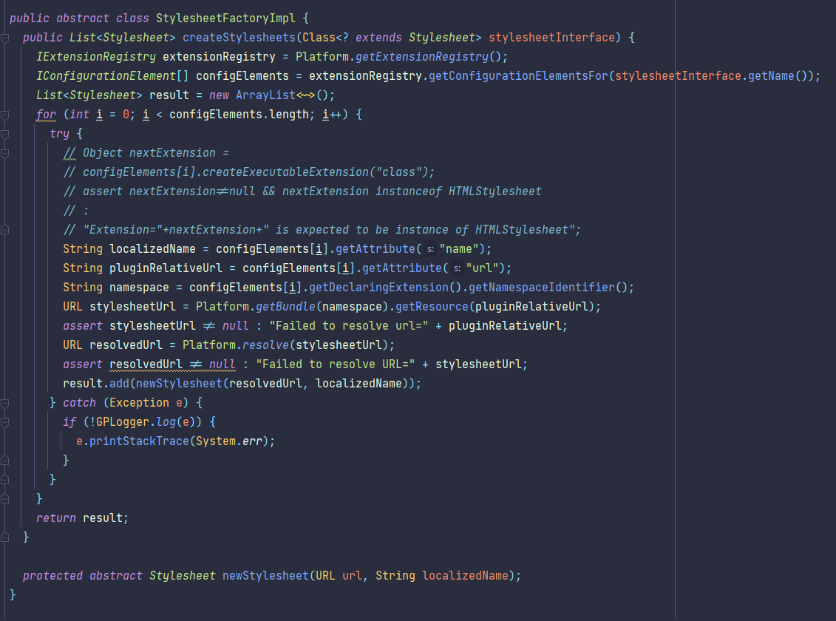

### Class location

/org.ganttproject.impex.htmlpdf/src/main/java/org/ganttproject/impex/htmlpdf/StylesheetFactoryImpl.java

### Explanation

This class is responsible for constructing lists of Stylesheets potentially of different types that share similarities and can be constructed provided an implementation of Stylesheet.

## Builder

### Illustrating code snippet

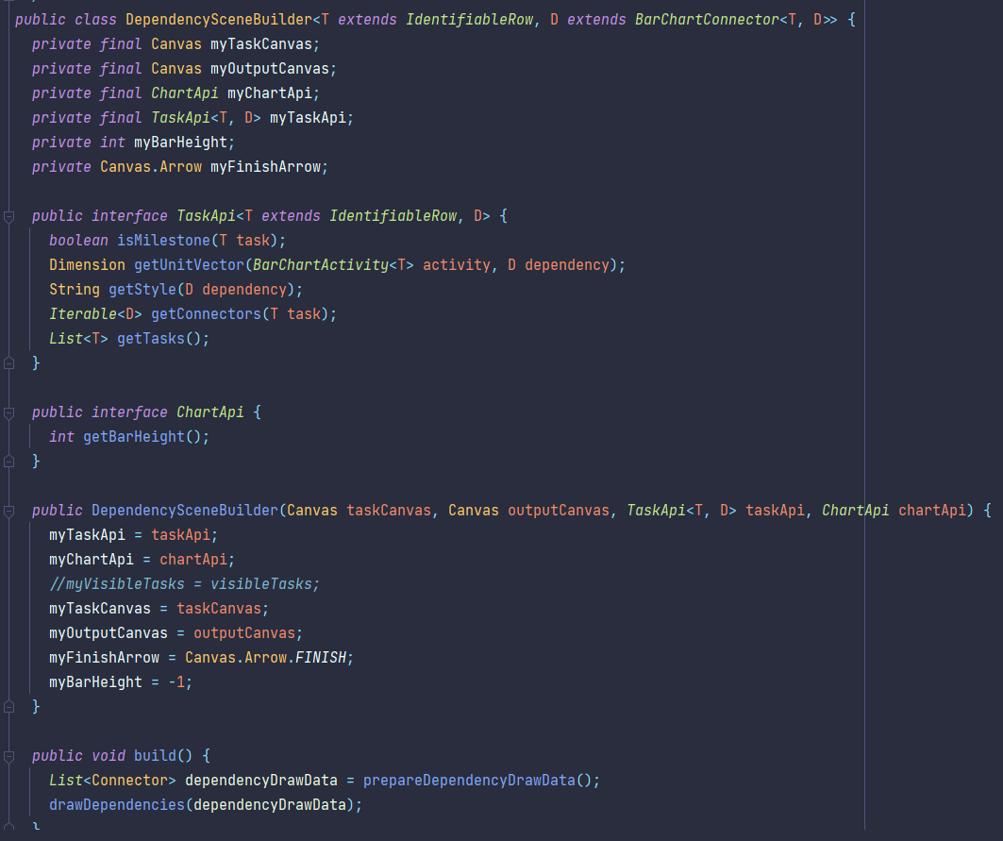

### Class location

/biz.ganttproject.core/src/main/java/biz/ganttproject/core/chart/scene/gantt/DependencySceneBuilder.java

### Explanation

This class is responsible for building something from a complex set of actions, separating its construction from its representation, in this case, dependency lines between tasks.

## Singleton

### Illustrating code snippet

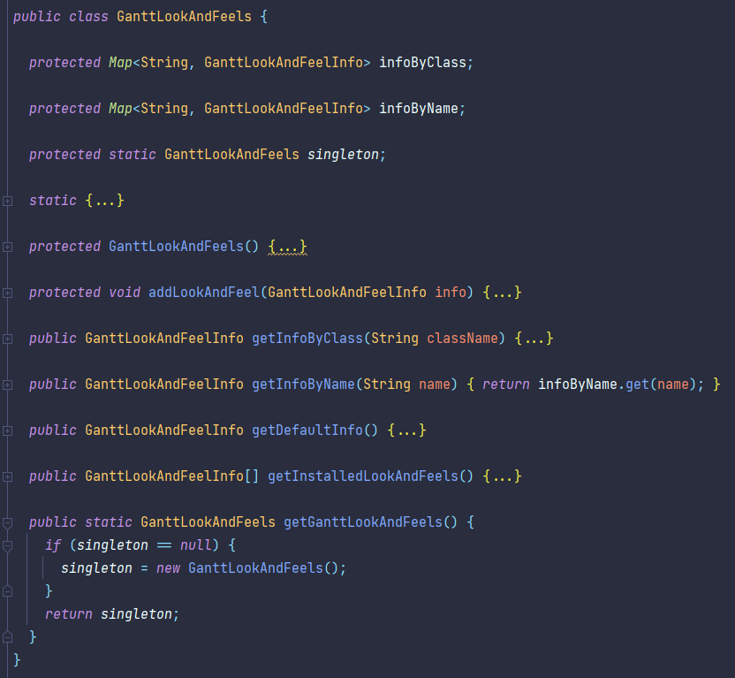

### Class location

/ganttproject/src/main/java/net/sourceforge/ganttproject/gui/GanttLookAndFeels.java

### Explanation

Limits the instantiation of its class to a single object, always providing the same underlying object on every call to *getGanttLookAndFeels()*.